1. PC

tg1553

* 1. Implementation

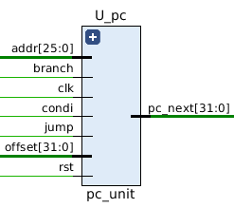Signal list:

in clk: clock signal

in rst: reset signal, active-high

in jump: pc_src select signal for JMP, active-high

in addr: address to jump

in branch: pc_src select signal for BXX, active-high

in condi: branch condition signal, active-high

in offset: offset to branch

out pc_next: address of next instruction

This is a 32-bit register that contain the address of the next instruction to be executed. pc_next will be updated synchronously under 4 different conditions, as show below:

|  |  |  |
| --- | --- | --- |
| Type | PC_next | Condition |
| Continuously | PC + 4 | jump=0 & branch=0 * |
| Branch | PC + 4 + offset*4 | jump=0 & branch=1 & condi=1 |
| Jump | (PC+4)[31:28] & addr & “00” | jump=1 & branch=0 |
| Halt | PC | jump=1 & branch=1 |

*\* full logic should be jump=0 & (branch=0 | (branch=1 and condi=0))*

* 1. Testbench

For each condition, I tested the PC unit on 1000 random cases and used ‘assert’ statement to check the output automatically (see tb_pc.vhd for details). The stage signal would change to FINISH only when all test cases passed, otherwise, the simulation would stop with severity level ‘failure’.

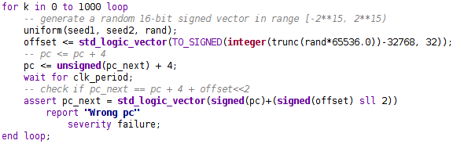

Figure 1.2.1 This is an example code of checking the branch condition

* 1. Functional simulation

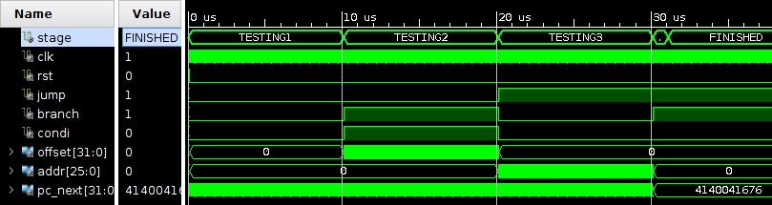

Figure 1.3.1 An overview. All cases passed.

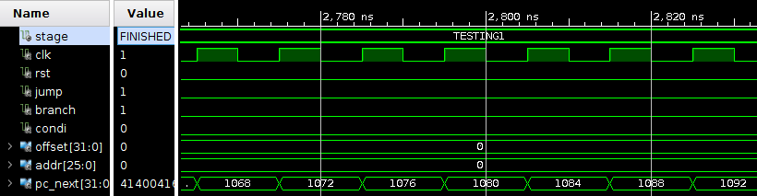 Figure 1.3.2 Testing continuously increment condition.

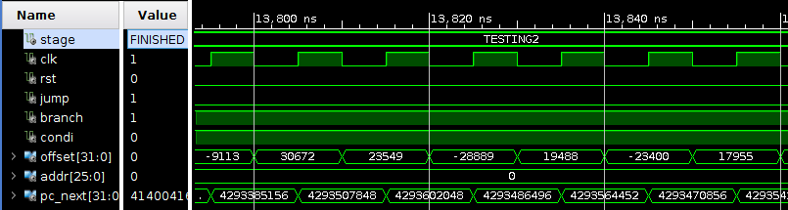 Figure 1.3.3 Testing branch condition

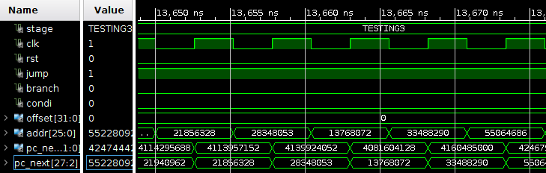

Figure 1.3.4 Testing jump condition

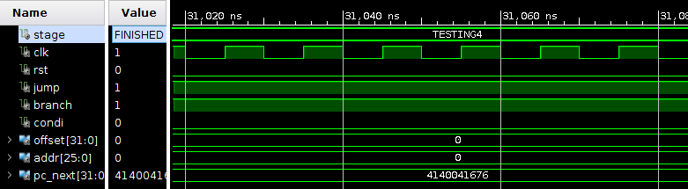

Figure 1.3.5 Testing halt condition

* 1. Timing simulation

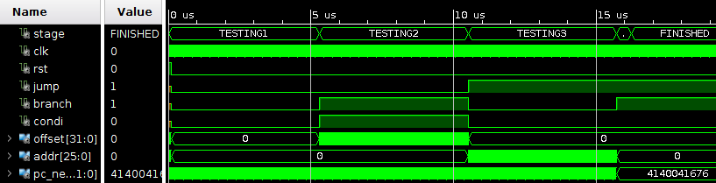

Figure 1.3.1 An overview. All cases passed.

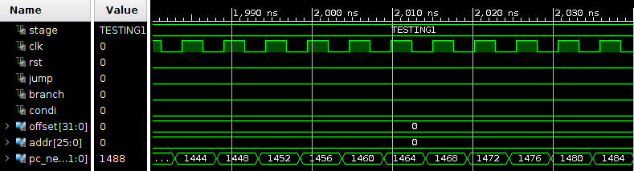

Figure 1.3.2 Testing continuously increment condition.

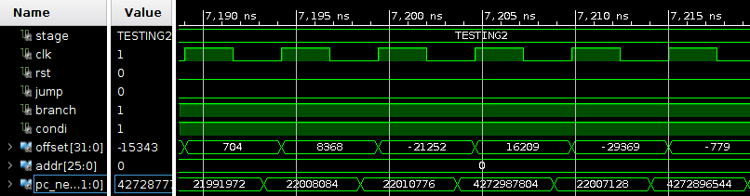

Figure 1.3.3 Testing branch condition

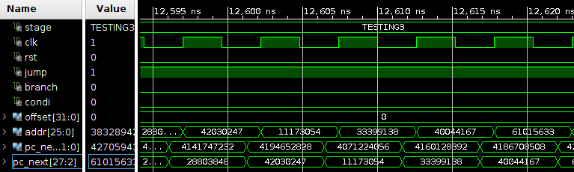

Figure 1.3.4 Testing jump condition

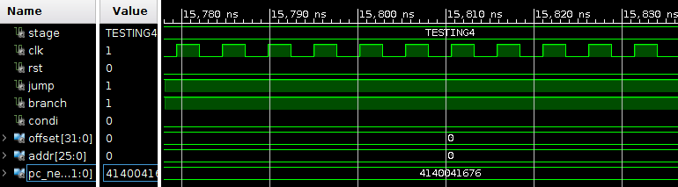

Figure 1.3.5 Testing halt condition

* 1. Timing analysis

|  |  |
| --- | --- |
| Critical path delay | 5.2 ns |
| Highest frequency | 192 MHz |